Chapter 3: Methodology

3.1 Introduction

The present chapter describes the methodology used in the construction and the validation of the automated vendor contract risk assessment tool. The construction and validation methodology combines design science research with practice and theory implementation through mixed validation methodology. There are and will be, throughout this chapter, explanations of how each of the methodological choices pertains to the research questions outlined in Chapter 1, and this will facilitate a cohesive and symmetrical linkage of the research questions.

3.2 Research Design and Philosophical Approach

The method of this project retains a pragmatist philosophical position due to its emphasis on practical outcomes of interest and the maintenance of methodological strictness. Considering the purpose of this project, the pragmatist approach works best as this project aims to find possible solutions to the challenges confronted by IT contractors when performing assessments of vendor contracts. The specific methodological framework is design science research, as it revolves around the creation and empirical testing of research artefacts meant to address a given set of challenges within a given organisation.

The objectives of the research explain the selection of design science research as the most appropriate method and as the most relevant framework to this research. It is one thing to contribute to knowledge the theory, but it is quite another thing to provide the knowledge the theory and the practice of a usable artefact. This design science research framework has been used extensively across IS research where the focus is to achieve the development of a relevant artefact or framework to address a specific problem or set of problems within an organisation.

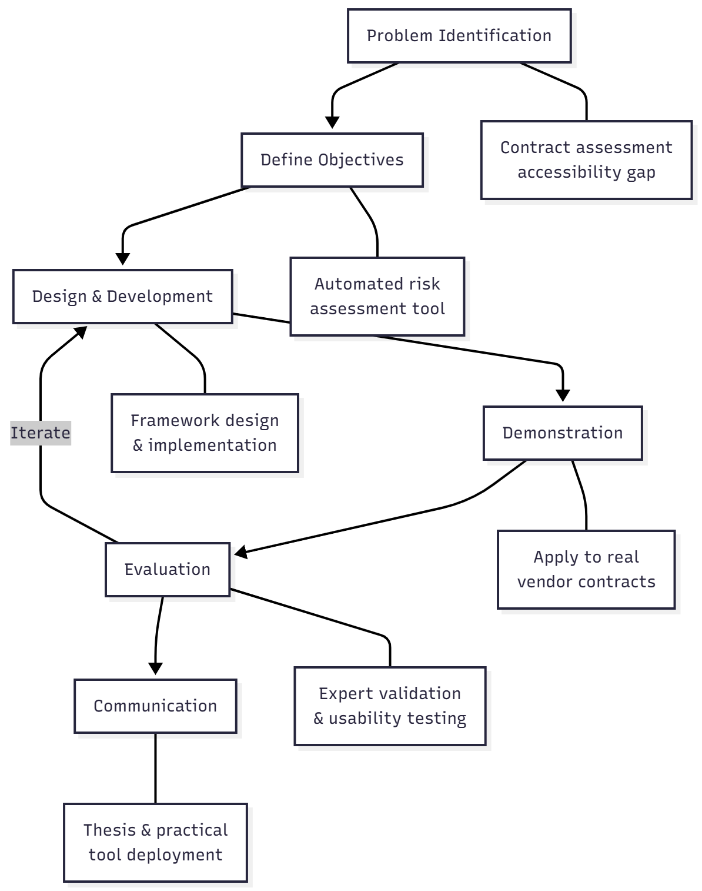

Figure 3.1: Design Science Research Process
3.3 Research Questions and Methodological Alignment

The methodology has been constructed to tackle each one of the research questions one at a time. For RQ1 focusing on the most common and harmful lock-in mechanisms in software vendor contracts, I conduct systematic content analysis of actual vendor contracts and academic literature. This allows to ensure that the clause types identified are in sync with theoretical and actual prevalence.

With RQ2, which explores whether there is a way to simplify the contract risk assessment for IT practitioners with no legal background, I conduct iterative design with usability testing. The methodology includes cognitive load and task completion analysis to ensure that the redesign provides a rationale for a substantial reduction in complexity while maintaining accuracy.

RQ3 focuses on assessing the degree of deviation of the prevailing automated framework from a traditional legal review. This requires the use of comparative validation methodology. I have a documented analysis of legal divergence from contract frameworks, and I use correlation analysis to quantify the divergence between the framework outputs and the legal review.

With regard to RQ4 which is focusing on assessing alignment with expert legal evaluations, the methodology includes a system for assessing inter-rater reliability and measurements of concordance. Pairs of legal practitioners evaluate the same contracts and their evaluations are compared to the outputs of the framework to establish agreement and accuracy.

RQ5, which seeks to understand organizations’ utilizations of the framework to obtain effective contract terms, involves qualitative analyses of outcomes of negotiations and the effectiveness of alternative clauses. This includes professional assessments of the alternative clauses and the suggested negotiations templates.

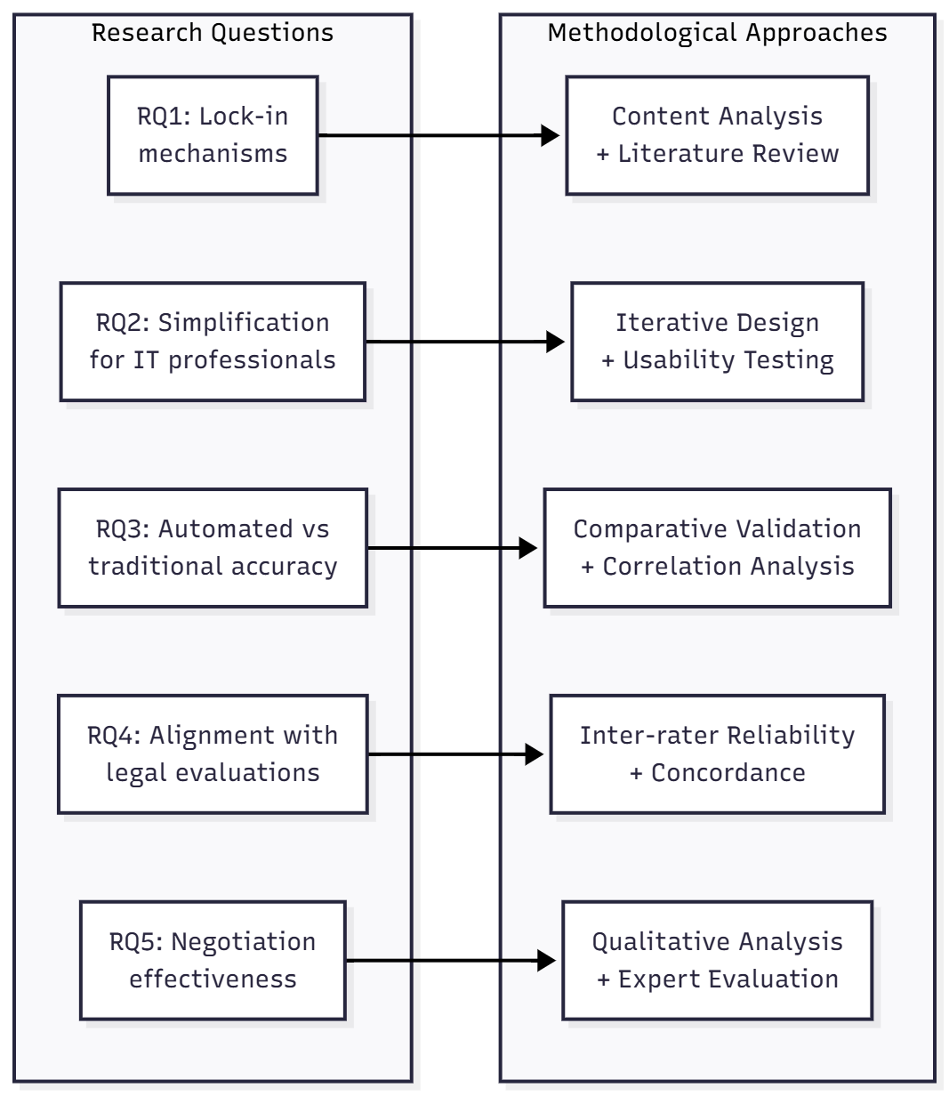
Figure 3.2: Research Questions and Methodological Alignment

3.4 Method Justification

The choice of a mixed approach with both a quantitative scoring validation and qualitative expert review makes sense given the complexities of evaluating the risk of a contract. A purely quantitative approach would miss the intricate nuances that come with evaluating a legal contract, whereas a purely qualitative approach would lack the measurable validation that would enable the determination of the accuracy of the framework.

The design science research approach is fitting for this study as it allows for the development and validation of usable research and practical contributions. While other research approaches may focus on describing and explaining findings that phenomena may exhibit, design science research approaches the outcome from the other end of the spectrum as it aims at the development of an artifact that optimizes a given practice. This congruence of the methodology and the research purpose of this study will result in both theoretical and practical contributions.

The iterative development method taken in this research design mirrors typical practices in software development and tool design. By having multiple feedback loops in the development of the framework, I aim for the end product to respond to real user needs rather than assumptions. This design method lowers the chances of arriving at a tool that is technically and theoretically robust, but one that misses the real practical needs of the target audience which in this case are IT practitioners.

3.5 Sampling Strategy

3.5.1 Contract Sample Selection

For vendor contracts, contract sampling uses purposive sampling, aiming for balance between larger software vendor providers and types of contracts. For the first phase of identifying contract clauses, I sample 50 vendor contracts from publicly available terms of service and PCs from software providers, including Amazon Web Services, Microsoft Azure, Google Cloud Platform, Salesforce, Oracle, SAP, ServiceNow, Workday, Adobe, and IBM.

The 50 contractual agreement sample size works with the concept of theoretical saturation in qualitative research. Based on preliminary research, saturation of clause pattern identification occurred after reviewing roughly 35-40 contracts. Additional contracts contributed very few new clause types. For the purpose of excess theoretical saturation within the sample universe, the scoped sample of contracts sits at 50, as it allows for enough contracted documents to be analyzed without exceeding the constraints of the project.

The contracts eligible for selection by these criteria should meet the following: (1) contracts should come from established software vendors with a considerable market impact; (2) contracts should be publicly available from vendor sites or their official documentadon repositories; (3) contracts should be for Software-as-a-Service or other cloud service agreements; (4) contracts must be in the English language. These selection criteria enhance the sample universe in terms of the contracts provided, while still meeting the research ethics framework by providing the most used type of SaaS contracts that IT professionals encounter.

To confirm the accuracy of the model created, I examine a fresh batch of 10 vendor contracts that do not pertain to the first phase of clause identification as a means of validation imbalance between development and validation samples to avoid overfitting and allows the model to learn to work with contracts beyond the ones used.

3.5.2 Framework validation approach

The scope of validation of the framework for this college project is based on a self-educational approach. The validation of the framework is as follows:

First, I conduct a thorough cross-referencing of clause patterns that have been identified with reference to other related scholarly works as well as legal writings on software licensing agreements. This is to confirm that the identified clause types and risk levels are consistent with the scholarly community.

Second, I conduct provisional self-assessment with the validation sample of 10 contracts which were not part of the development phase. This is to confirm that a balance has been achieved. Samples of contracts have also been used to avoid overfitting demonstrating the framework has utility across a diverse contracts.

Third, the framework is applied personally to several contracts to gauge its utility, to record the time taken for its analysis and the level of ease experienced or to note the difficulties encountered.

To evaluate the precision and applicability of the risk classifications, I contrast the framework outputs with publicly accessible contracts analysis guides as well as documents on best practices by the industry.

Even though this method lacks external validation, the self-directed validation approach still offers a thorough, exhaustive, and structured approach for the determination of the framework’s reliability and the limitations of a single academic endeavour.

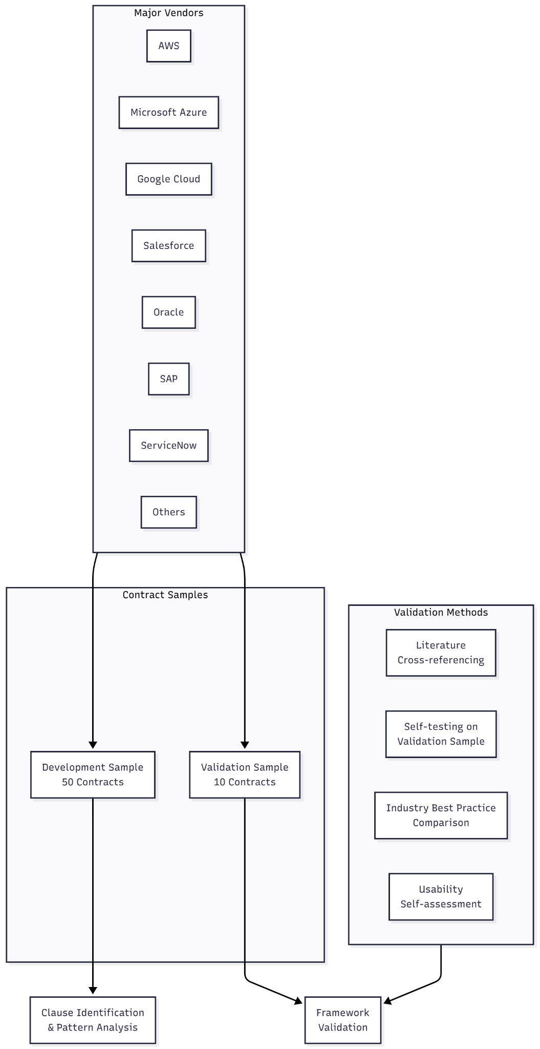
Figure 3.3: Sampling Strategy Overview

3.6. Protocols for the Collection of Information

3.6.1 Contract Collection and Documentation

All contracts with vendors are obtained via transparent and replicable processes. Contracts that are public and can be accessed are obtained from vendor sites, with timestamped dates. For each contract, I record the name of the vendor, type of the contract, date modified, URL from which it was sourced, and date of download. This documentation can be used for tracking and verifying the research.

All contracts are obtained from vendor websites and documentation repositories that are public. This method of collecting data adheres to research ethics protocols and does not require additional permissions or relationships with the business. All contracts are processed for machine-readable text using optical character recognition, when appropriate. I verify that the conversions are correct by reviewing a few different places throughout the document. I do not include in the sample any contracts that have a large number of errors in the conversion.

3.6.2 Protocol for the Identification of Clauses

The identification of clauses uses a pre-defined, systematic approach of content analysis. The entire contract is read, and the relevant clauses are highlighted and pulled into a template that consistently holds the extracted information, which includes text of the clause, type of clause, position, and some notes about potential risk. I do the identification of clauses in two steps. On the first step, I collect all clauses that may pertain to the subject without regard to the classification.

In the second phase, I classify the detected criteria into the five main groups: data portability provisions; pricing and payment terms; support obligations; termination and exit clauses; service level agreements. Division of analysis this way mitigates the chances of early categorization affecting the identification of clauses. For the purposes of maintaining uniformity in the coding processes, I draft a coding standards document prior to performing the analyses. I then select a random group of ten contracts two weeks post the completion of my primary coding to assess intra-coder reliability. This system is designed to manage the synchronicity of my coding throughout the duration of the project. Any discrepancies arising from the system are investigated, and this informs the development of the guidance to improve the system.

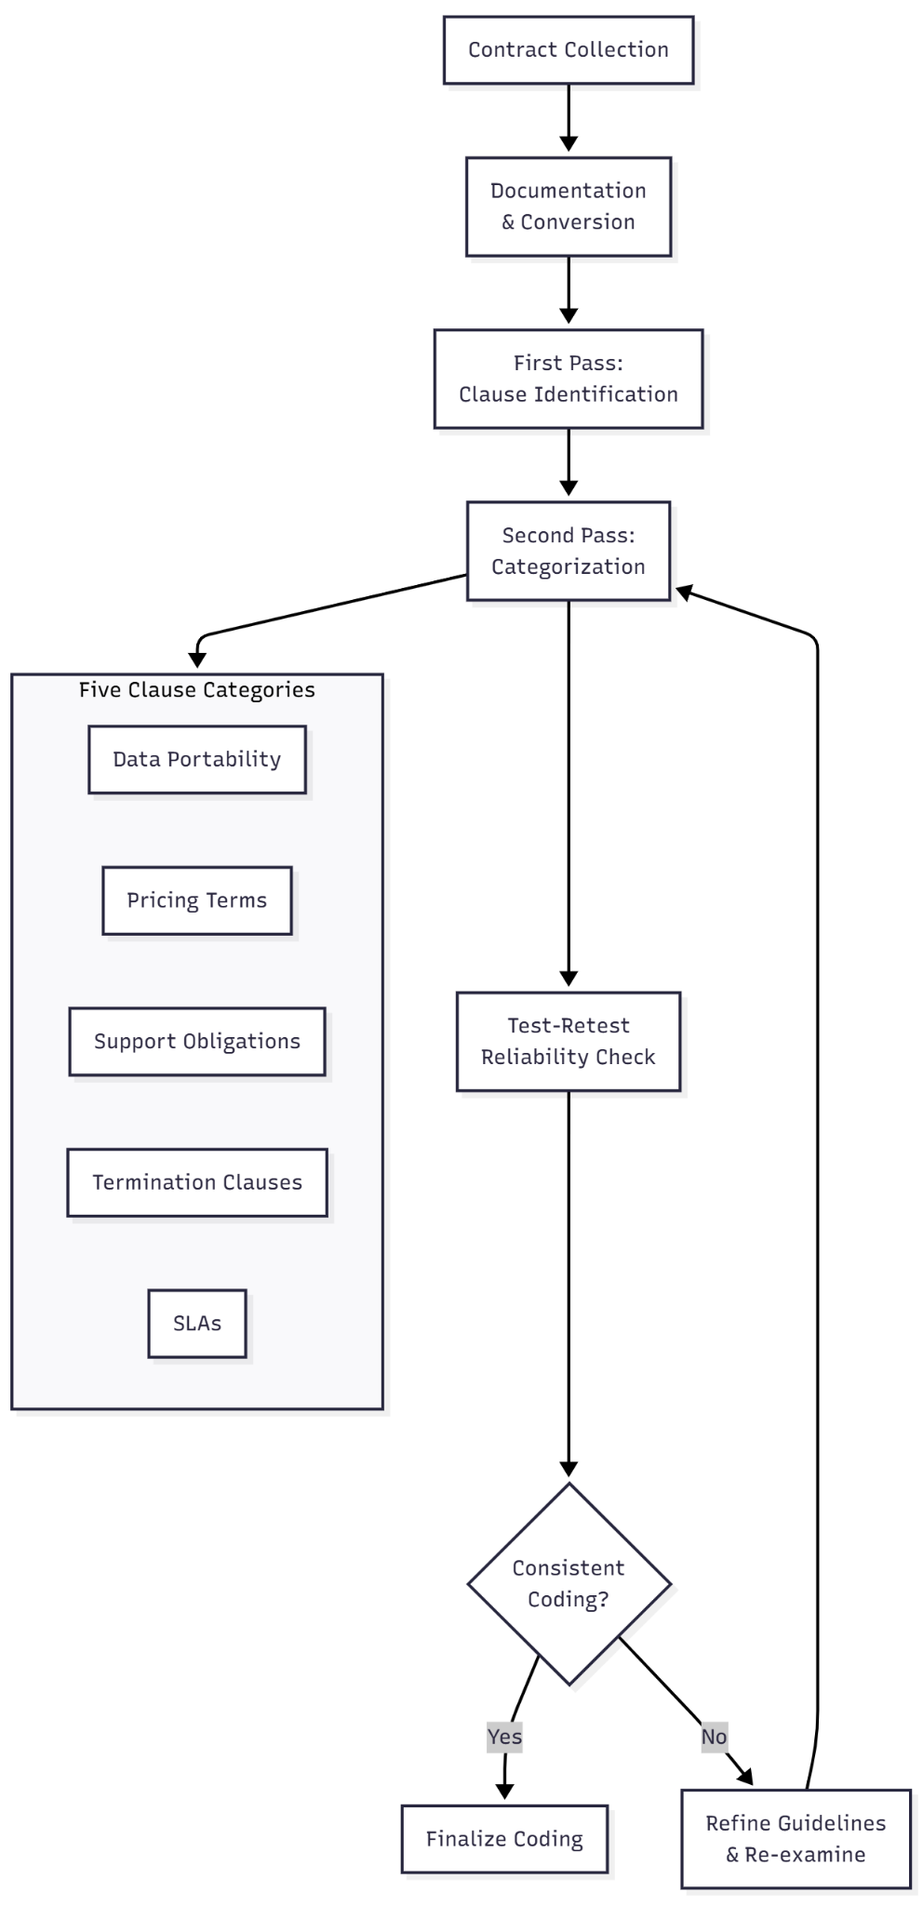
Figure 3.4: Data Collection and Analysis Workflow

3.6.3 Self Validation of The Framework.

The validation is done in comparison to what is considered relevant frameworks in the literature. Validation in this case is an individual self learning academic project.

I have approached the framework to 10 validation contracts and document the resultant risk assessments. These contracts assessments are compared to the publicly available ones, the guides to contracts, the legal commentaries, and other documents describing the contracts in the literature, and the analysis is documented. Then, I determine, and document the analysis of the differences as an improvement opportunity and assess the differences for the opportunity to provide an improvement to the framework.

The risk classifications in the framework are compared to the literature on vendor lock-in and software licensing, and I focus on this as well. Because the framework outputs align with the literature on contract risk assessment, this literature review is validation.

3.6.4 Usability Evaluation Procedure

I assess usability through self testing and self documenting.

I systematically apply the framework on a number of contracts, describing the specific observations, one at a time, referring to the framework’s adoption by a specific user.

I time the task on a stopwatch, record total time spent, if I encountered any issues, and if I experienced any difficulties. I self-analytic to provide data on how the framework can be modified for less friction.

I detail every step in the framework, identifying where a new user would struggle the most, in order to know what issues I need to address in the user interface, and what changes need to be implemented so that the user can have a more seamless experience. These changes are influenced by cognitive walkthroughs in the context of human-computer interface.

3.7 Coding methodology

Using my thematic self-analysis framework, I analyze the results of my self-test observations in conjunction with the literature. I used inductive rather than a priori coding so that the appropriate codes would emerge from the documents and data rather than be imposed. This allows the analysis to remain receptive to the genuine structural patterns rather than have the data artificially censored to align with an ideological bias of the researcher.

Data analysis is done in a set of six stages, consisting of the internalization of data, production of initial codes, and then data is advanced through a series of patterns to identify key themes to the development of details, the naming of patterns, and the data collection at the end of the entire process to form a coherent report. I have to record data in various spreadsheets since they are the most accessible when I need to retrieve my qualitative data.

To maintain qualitative rigor, I have a detailed tracking of my entire coding process and the steps I took to formulate each theme. This is the audit trail that I created.

The audit trail confirms the steps taken during the analysis, which amplifies the credibility of the qualitative findings.

Within a theme, negative case analysis contributes to depicting the counterargument that can be examined. The purpose of the negative case is to complete the conceptualizations of the negative cases to portray a complete set of findings, rather than findings that only narrate the story in support of the case.

3.8 Scoring System Development and Justification

3.8.1 Scoring Framework Design

The scoring approach is a point-based system in which each clause category is given a certain score based on risk and how prevalent that risk is, which is reflected by the final score, which is an aggregated risk rating of the contract, which can be Low, Medium, or High. This approach is defensible as it is straightforward and simple, not only in terms of the explanation, but also in how the risk rating was derived as it can be traced to the specific points for each clause.

Each of the five clause categories, data portability, pricing terms, support obligations, termination, and service level agreements, allocation of points also deals with how serious the clause was as the limit-securing clause. The worse the clause was, the higher the points.

3.8.2 Weight Justification

The allowance of each clause category to have the same weight (20 points each) is not intended to be a methodological choice, but instead, to avoid distributing researcher discretion of relative significance. Different prioritisation of risk factors is a common practice across various organisations. For instance, a healthcare organisation is likely to concentrate on data portability, while a startup is more likely to prioritise pricing flexibility. Equal weighting mitigates the risk of the framework incorporating contextually irrelevant assumptions.

Point allocation in each category is based on an extensive analysis of literature, reports, and entries from guidebooks on vendor contract risk. The analysis is reviewed from different angles. The varied harshness of particular clause wordings has been evaluated from several prominent authorities. A literature-driven approach was implemented demonstrating that point allocations among peers in the profession is not arbitrary, but rather, reflects a consensus viewpoint.

3.8.3 Threshold Justification

The point threshold on each risk category is 0-33 points which is ranked Low, 34-66 Medium; 67-100 High. This distribution lends itself to fair distribution of risk scores. Thus, the thresholds spilt the range of scores into three equal parts and this is how a fair distribution is achieved, ensuring that there is no equal systematic bias to any particular risk category.

The proposed threshold values are first applied to a sample validation contract and then compared to the appropriate risk assessment benchmarks in contract analysis. To ensure the cross-sectional views specific to the industry are in line with the risk bands in the framework, I adjust the thresholds iteratively. This literature-based calibration ensures thresholds are not arbitrary values, representing a coherent risk stratification.

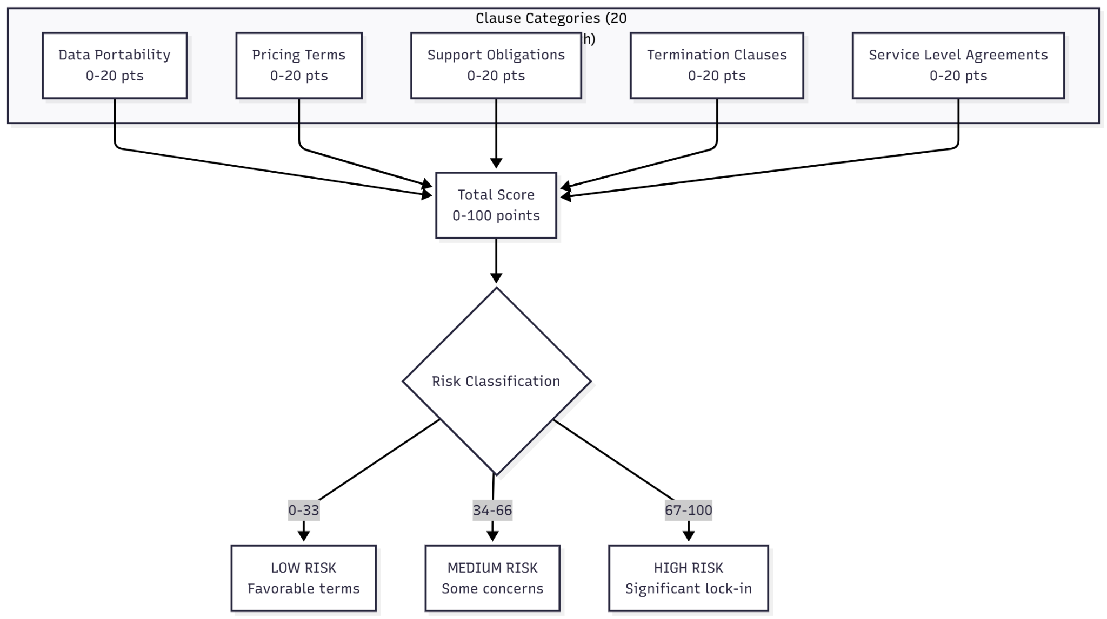

Figure 3.5: Scoring System Structure

3.9 Technical Design and Development

3.9.1 System Architecture

The infrastructure has been designed in form of a web application to facilitate use. The architecture is structured in a three-tier model consisting of a presentation layer, business logic layer and data layer. This division of concerns allows modifiability and ease of change to individual layers and facilitates scalability.

Presentation layer uses a responsive front end so that it is easy to use in both desktops and mobiles. Data and Information are structured in an orderly manner to avoid information overload, and users are presented with just enough detail to give the necessary information without overwhelming complexity. The design of the interfaces and overall system was guided by principles of usability so that self testing of the system (the developers using the system) can be used to check usability of the system.

The business logic layer contains scoring algorithms and the logic for the risk assessments. This layer takes information that the users enter, applies scoring criteria to it, and produces risk reports. Implementation is done in Python because it has useful libraries that support natural language processing, and document retrieval and manipulation.

This data layer is composed of the databases for the different sections of the contract clauses, scoring metrics, and histories of users assessments. I used a relational model to enable quick data retrieval, and convenient data manipulation for reporting. The design of the schema is data to be out of the box to accommodate new features such as more types of clauses to continue to be added, and more complex scoring to be added.

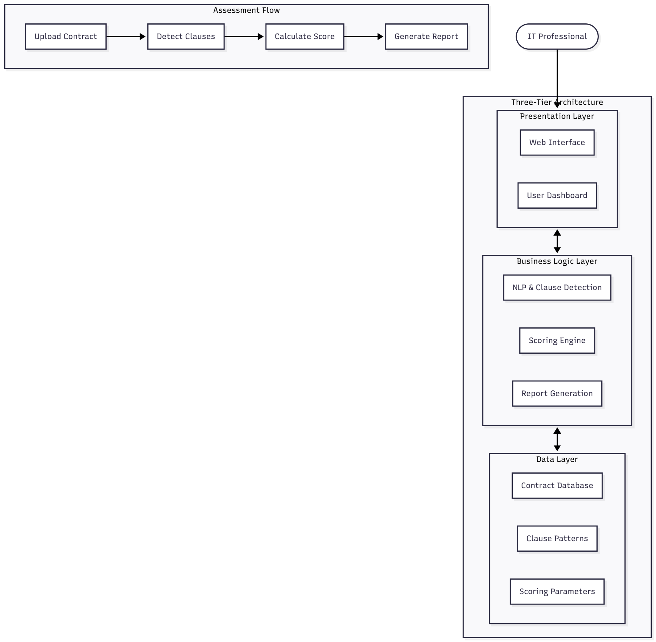
Figure 3.6: System Architecture and Core Functionality

3.9.2 Core Functionality

The framework includes four main functions: guided assessment, automated clause detection, risk scoring, and report generation. Guided assessment walks end users through their vendor contract and asks them simple, non-legal, and structured questions. This function employs keyword detection and pattern recognition to flag risky clauses for users. The automated systems are trained on clause patterns found during the content analysis stage.

Risk scoring takes the validated scoring system and applies it to the user’s answers and detected clauses, resulting in category scores and an overall risk score. The scoring methodology is visible to the users and they can see the score breakdown.

Report generation allows complex risk assessment reports to be created, which can be used for business decision making. The reports include an overall risk score, risk category breakdowns, specific clauses of concern, and negotiation strategies. The reports are easily distributed, archived and are in PDF format.

3.9.3 Development Process

The project implements an iterative process model with a cycle of reviews and refinements. Every cycle of the iteration yields a working piece that is assessed and refined from the viewpoint of the dev team, and from the overall project goals. Such an approach helps ensure that the progress of development adapts to the new goals and challenges that emerge throughout the project instead of sticking to the initial set of requirements.

All code modifications are recorded and kept in a separate branch using Git, which also allows me to oversee development in an orderly manner and to counteract some problems by reverting to an earlier save. Such branching is helpful to keep working on uncompleted features without getting in the way of the main development which is being refined. Because of the requirement of proper documentation, the code will also be useful to other researchers and developers down the line.

Coverage should be no less than 80% for any development cycle and tracking should be done for any problems. Some have to be fixed for the next cycle and some can be done for future cycles.

3.10 Ethical Considerations

This research has been conducted following the ethical guidelines discussed by the faculty. The research relies only on publicly available vendor contracts and does not involve human subjects, and thus it did not require formal ethical approval. Regardless, all research activities remain in accordance with the institutional guidelines on ethical research conduct.

Vendor contracts are dealt with in a manner that respects commercial confidentiality. This research only uses contracts that are public and are available via the vendors’ official websites. This research does not use any proprietary contract clauses obtained via private commercial arrangements, so this research is fully compliant with the no contracts and confidentiality agreements.

This research does not involve the use of deception, does not involve any vulnerable subjects, and involve no risk to subjects. The only remaining ethical concern is that the framework is not represented, in a misleading manner, as a substitute for legal advice. Every single output of the framework has a disclaimer that is unequivocal that the tool is a complement to legal services for contracts that are high-risk, and does not substitute a legal practitioner.

Furthermore, I take care to cite all the sources correctly, and that the research has not been conducted in a way that would misrepresent the findings by omission, or on selective reporting. Integrity has been rigorously observes in the conduct of this research.

3.11 Validity and Reliability

3.11.1 Internal Validity

Internal validity is addressed via specific means, in this case, traceable forms of documentation. Established protocols in content analysis, standardized processes in data collection, and documented decisions in coding guarantee that findings are data-driven and not research bias.

Use of triangulation concerning internal validity. Comparing findings from the contract analysis to the conclusions of the literature review, and matching outputs to frameworks with the risk analyses of the published analyses, assessments is triangulation.

While maintaining reflexivity is also a challenge. These include assumptions, expectations, and potential biases are documented as part of a research journal to facilitate self-testing of how these factors might affect interpretation, analysis, and evidence of these practices. Support reporting transparency.

3.11.2 External Validity

In External validity this is part of the factors I will consider is that the framework has, to a degree, been developed using contracts from the larger software vendors, and therefore, might not be fully generalizable to the more niche or emerging vendors. The purposive sampling strategy tends to focus more on representing the common contract types rather than representing all the possible variations in their entirety.

Considering the conflicts of laws issues the study's geographical scope is limited to contracts governed by the common laws of the USA, the UK, and Ireland. Specific arrangements for the practical implementation of the framework will be needed for organizations in other jurisdictions, since they operate under other legal systems and will have other principles of contract law.

3.11.3 Reliability

The documentation and other materials that were used for this study, including the protocols for the collection of the data, the procedures for coding the data, and the methodologies used for the analysis, were written in a way that is so detailed that another researcher would be able to follow the documentation, and by doing so, be able to achieve the same results as those that I achieved, or be able to reproduce all or a maximum amount of the results that I have achieved.

The evidence of consistency for the intra-coder reliability is measured. The consistency of the coding of contracts is evident in the results of the test-retest reliability assessment, whereby I re-code a sample of the contracts after a specific period of time. The consistency of the coding is also supported by the correlation of the results of the framework with the results of the contract analysis published in the reviewed papers.

3.12 Limitations

There are some limitations present in this research. One such limitation is that the purposive sampling strategy, while ensuring representation from the major vendors, may still not include major clause patterns that can potentially be present in the contracts of smaller or specialised vendors. Thus, organisations working with niche vendors will need to understand that the framework will not be able to identify all risks relevant to them.

Another limitation is that the self-validated approach to the research framework, while being systematic and rigorous, will still lack the external validation that could be delivered through the critique of independent experts in the field. It is understood that the assessment of the framework’s validity through published sources, rather than being independent and asking, may not be sufficient and may reduce the range of confidence in the validation.

Another limitation to this approach is the single-researcher design, which can lead to bias from that single researcher in the selection, categorisation and interpretation of clauses. Thankfully, reflexive practices and systematic protocols to reduce bias are in place, but it would be great to have independent supporting research to improve the support for the findings.

Additionally, the methodology used to validate the research framework looks at validating it, for accuracy, based on a single moment in time. It is recognised that vendor contract practices will change from that moment in time, and for the framework to remain accurate, it is this research that will be expected to provide guidelines for updating and maintaining the research.Fifth, the research does not provide a sustained analysis of the outcomes of the organisation. Even though the framework is confirmed to be consistent with the range of perspectives on risk identification, I will not be able to determine if the framework is used to obtain better contract terms or less vendor-related costs, and I will not measure it over time. Measuring such outcomes would entail a time commitment beyond what this project is able to provide.

Sixth, the capabilities of natural language processing to automate clause detection is less than what is theoretically feasible. Detection algorithms may fail to identify clauses that are simply written in a different style, and may even identify clauses that are not problematic. Users need to manually check the clauses that have been flagged to ensure that they are not problematic, instead of stopping their review when the automation tool has identified clauses.

Seventh, the usability assessment relies on self-testing rather than observing actual end users. Although the cognitive walkthrough and self structured assessment are good practices that can yield useful results, they may not be able to uncover potential difficulties that real IT professionals of different backgrounds might face when navigating the framework.

3.13 Summary

The chapter gives an account of the methodological framework developed for the construction and validation of the automated vendor contract risk assessment tool, integrating the principles of the design science research methodology with self-validated methodology. The integration of design science with self-validated research methodology has allowed for a pragmatic solution and the aacademic scrit through the design of a single college project. Self-validated methodology, then, helps determine the validity of the framework, the proof of which is in the design for proof of concept. Primary validation is by purposeful sampling of 50 vendor contracts and a secondary validation by a validation sample of 10 contracts to determine clause accuracy. The scoring system is described within a framework built of a contract review system to which a set of document analysis literature and empirical thresholds are utilized to edit the scoring parameters. Recognized and open data sources, combined with a transparent approach to research, frame the ethical context. Limitations must be considered for reasonable scope and context in which research is to be used and are explained in the text. The design of the framework is next and is discussed in terms of typology of clauses within the contracts, scoring rubrics, and negotiation templates.

